I233018
AbdulBasit
Lab14

task1:

CODE:
#include<unistd.h>
#include <semaphore.h>
#include <stdio.h>
#include <pthread.h>
sem_t semaphore;
char message [] = "This is a shared message printed from : ";
void* printer(void * args)
{
sem_wait(&semaphore);
printf("%s %zu\n",message,pthread_self());
sem_post(&semaphore);
}
int main()
{
pthread_t t1,t2;
sem_init(&semaphore,0,1);
pthread_create(&t1,NULL,printer,NULL);
pthread_create(&t2,NULL,printer,NULL);
pthread_join(t1,NULL);
pthread_join(t2,NULL);
sem_destroy(&semaphore);
}

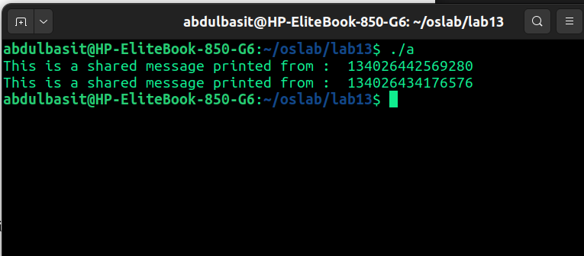
task2:

CODE:
#include <unistd.h>
#include <semaphore.h>
#include <stdio.h>
#include <pthread.h>
#include <stdlib.h>
#include <time.h>

sem_t semaphore;
int value;

void* producer(void * args)
{
value = rand() % 100 + 1;
sem_post(&semaphore);
return NULL;

}
void* consumer(void* args)
{
sem_wait(&semaphore);
printf("The number produced is : %d \n",value);
}

int main()
{
srand(time(0));
pthread_t t1,t2;

sem_init(&semaphore,0,0);

pthread_create(&t1,NULL,producer,NULL);
pthread_create(&t2,NULL,consumer,NULL);

pthread_join(t1,NULL);
pthread_join(t2,NULL);

sem_destroy(&semaphore);

}

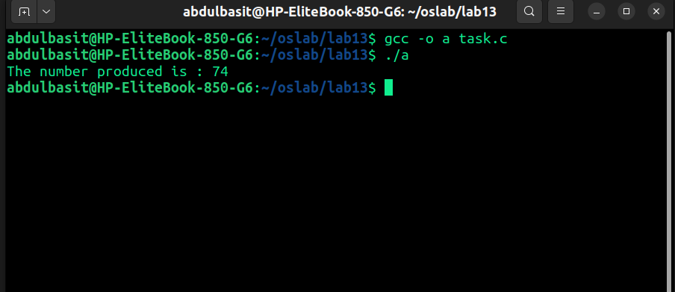
task3:
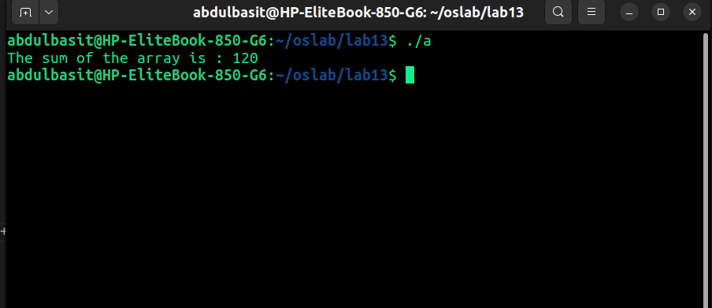
CODE:
#include <unistd.h>
#include <semaphore.h>
#include <stdio.h>
#include <pthread.h>
#include <stdlib.h>
#include <time.h>

sem_t semaphore;
int TOTAL_SUM;

typedef struct
{
int arr[15];
int startPoint;
int endPoint;
}array;

void* summation(void * args)
{
array* temp = (array*) args;
sem_wait(&semaphore);
for(int i=temp->startPoint;i<=temp->endPoint;i++)
TOTAL_SUM+=temp->arr[i];

sem_post(&semaphore);
}

int main()
{
array a1,a2,a3;
for (int i=0;i<15;i++)
{
a1.arr[i]=a2.arr[i]=a3.arr[i]= i+1;
}
a1.startPoint=0;
a1.endPoint=4;
a2.startPoint=5;
a2.endPoint=9;
a3.startPoint=10;
a3.endPoint=14;

pthread_t t1,t2,t3;

sem_init(&semaphore,0,1);

pthread_create(&t1,NULL,summation,(void*) &a1);
pthread_create(&t2,NULL,summation,(void*) &a2);
pthread_create(&t3,NULL,summation,(void*) &a3);

pthread_join(t1,NULL);
pthread_join(t2,NULL);
pthread_join(t3,NULL);

printf("The sum of the array is : %d \n",TOTAL_SUM);

sem_destroy(&semaphore);

}

TASK4:
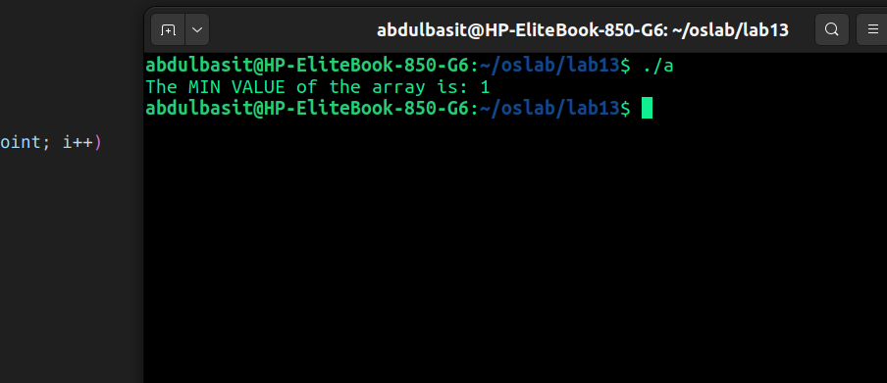
CODE:
#include <unistd.h>
#include <semaphore.h>
#include <stdio.h>
#include <pthread.h>
#include <stdlib.h>
#include <limits.h>

sem_t semaphore;
int MIN_VALUE = INT_MAX;

typedef struct
{
int arr[15];
int startPoint;
int endPoint;
} array;

void* summation(void * args)
{
array* temp = (array*) args;
sem_wait(&semaphore);
for (int i = temp->startPoint; i <= temp->endPoint; i++)
{
if (temp->arr[i] < MIN_VALUE)
{
MIN_VALUE = temp->arr[i];
}
}

sem_post(&semaphore);
return NULL;
}

int main()
{
array a1, a2, a3;
for (int i = 0; i < 15; i++)
{
a1.arr[i] = a2.arr[i] = a3.arr[i] = i + 1;
}

a1.startPoint = 0; a1.endPoint = 4;
a2.startPoint = 5; a2.endPoint = 9;
a3.startPoint = 10; a3.endPoint = 14;

pthread_t t1, t2, t3;

sem_init(&semaphore, 0, 1);

pthread_create(&t1, NULL, summation, (void*)&a1);
pthread_create(&t2, NULL, summation, (void*)&a2);
pthread_create(&t3, NULL, summation, (void*)&a3);

pthread_join(t1, NULL);
pthread_join(t2, NULL);
pthread_join(t3, NULL);

printf("The MIN VALUE of the array is: %d\n", MIN_VALUE);

sem_destroy(&semaphore);
return 0;
}

